2A/B PHYSICS
INVESTIGATION - RESISTIVITY

Background

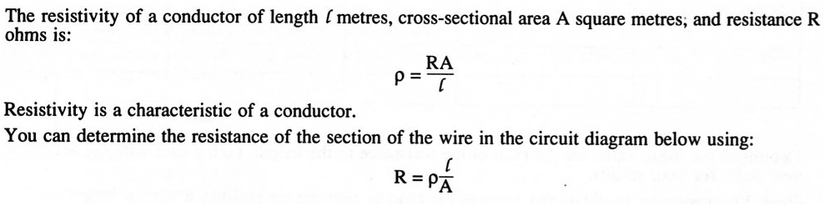
Purpose

The aim of this investigation is to determine the type of metal used as a conductor, based on its resistivity. You will need to gather data in your group, but each person should then be able to complete the analysis on their own.

Method

The method below is a guide to use to determine the type of metal used.

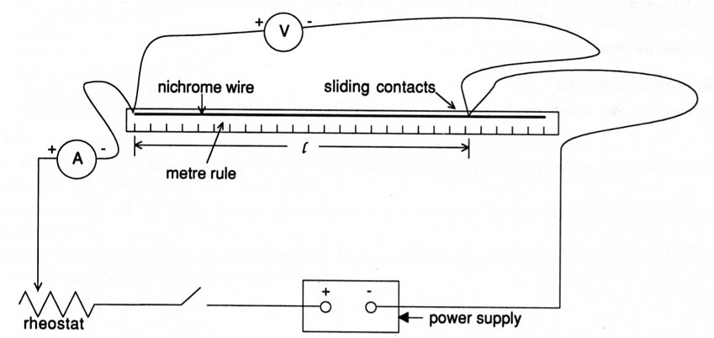

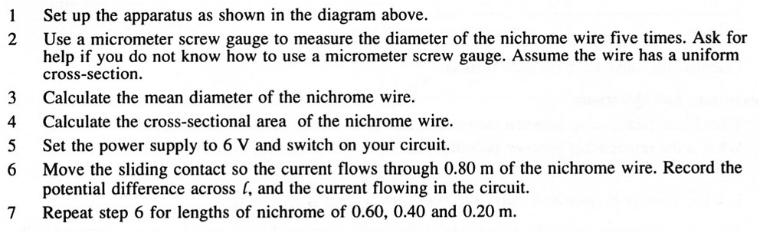
Processing

The table below is a suggestion only to record sufficient data to determine the resistivity of the metal.

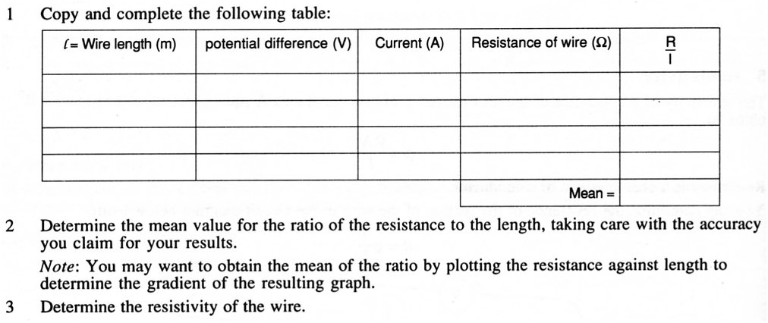

Write-up

Attached is a scaffold that you must use to present your investigation. Each section must be completed in an appropriate way.

